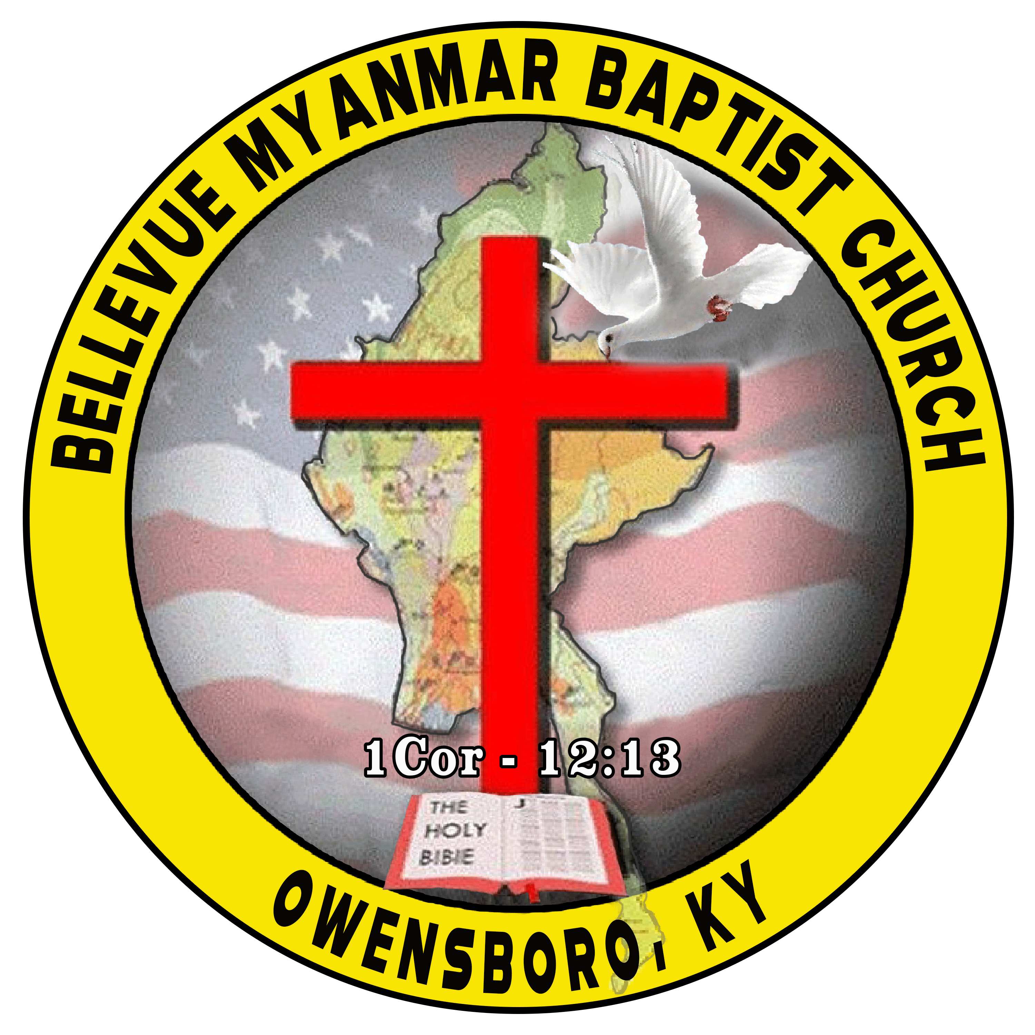 **BELLEVUE MYANMAR BAPTIST CHURCH (BMBC)**

**4950 State Route 56 Owensboro, KY-42301**

Dated. -----------------------

**To.**

Manager or HR

------------------------------------------------

------------------------------------------------

------------------------------------------------.

**To Whom It May Concern**

Dear Sir/ Ma’am,

Please-excuse Mr/Mis/Mrs. ---------------------------------------------------------------------------------,

from work from -------------------------- to -------------------------------- due to the death of his/her

-------------------------------------------,---------------------------------------------------------. The memorial

service will be held on -----------------------------------------------------.

Should you have any questions, please feel free to contact me @**918-954-5850** or Email:**kamlenhaokip@gmail.com.**

Sincerely

( )

Rev.Kam Len Thang