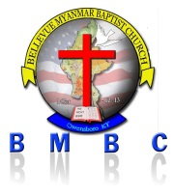
BELLEVUE MYANMAR BAPTIST CHURCH (BMBC) ( I Cor 12:13 )
Owensboro,KY-USA Date / /

အတြင္းေရးမွဴး ဥကၠဌ
BMBC အသင္း BMBC အသင္း
Owensboro,KY Owensboro,KY

