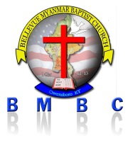 BELLEVUE MYANMAR BAPTIST CHURCH (BMBC) ( I Cor 12:13 )

Owensboro,KY-USA Date / /

အတြင္းေရးမွဴး ဥကၠဌ

BMBC အသင္း BMBC အသင္း

Owensboro,KY Owensboro,KY