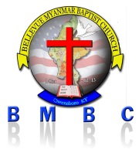 BELLEVUE MYANMAR BAPTIST CHURCH (BMBC) ( I Cor 12:13 )

Owensboro,KY-USA Date / /

Ref : ……………………………………………………..

To. WHOM.IT. MAY.CONCERN:

Please-excuse-………………………………….. From.work. From. …………………………..to…………………………... due.to.the.death.of.his.brs.brother

NAME. The.memorial.service.will.be.held.on ………………………...

Any.questions, please.feelferr.contact………………………………………………..

Sincerely.yours,

Scretary President

BMBC , Church BMBC , Church

Owensboro,KY Owensboro,KY